**Exercise 5: Feature Enhancement with Limited Context**

### **Objective:** Enhance your javascript project by adding a logging feature to track user actions—even when the code has minimal context or documentation.

## **Step-by-Step Instructions**

### **Review the Existing Code**

* 1. Open index.js in VS Code.
  2. Look for a function or section that lacks documentation.
  3. Add a comment like:

| // Need to add logging to track user actions here |
| --- |

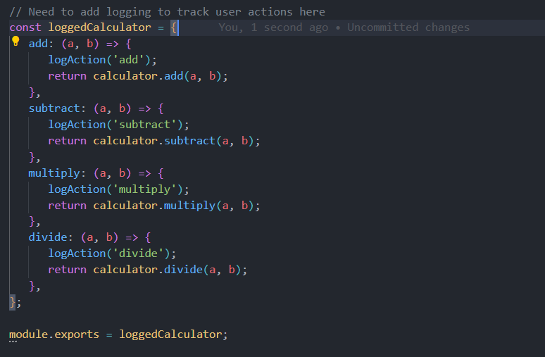

### **Define the New Feature**

* 1. Decide that you want to add a logging function which writes a message to a file named activity.log.

### **Write Tests for the New Feature**

* 1. Open index.test.js.
  2. Insert a comment:

| // Test for logging feature |
| --- |

* 1. Write a simple test:

| const fs = require('fs'); const { logAction } = require('./index');  test('logs action to activity.log', () => {  // Remove existing file content if needed  if(fs.existsSync('activity.log')) {  fs.writeFileSync('activity.log', '');  }    logAction("Test action");  const contents = fs.readFileSync('activity.log', 'utf8');  expect(contents).toMatch(/Test action/); }); |
| --- |

* 1. Allow Copilot to suggest improvements if available.

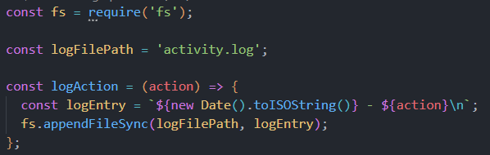

* 1. Save the test file.

### **Implement the Logging Feature**

* 1. Return to index.js.
  2. Add a comment:

| // Implement logging to record user actions |
| --- |

* 1. Use Copilot to generate a function. For example:

| def log_action(action):  with open("activity.log", "a") as file:  file.write(f"{action}\n") |
| --- |

* 1. Accept the suggestion and adjust as necessary.

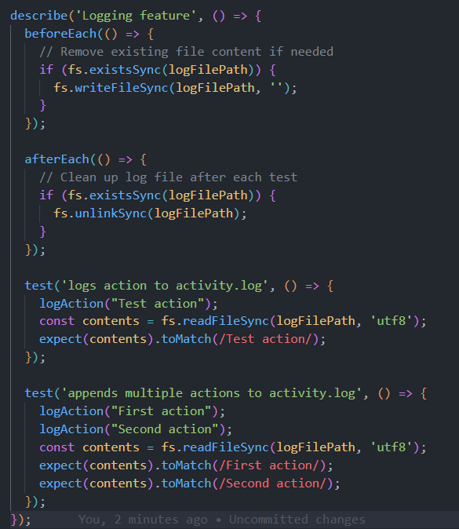

* 1. Save the file.

### **Run and Verify**

* 1. Run your tests (e.g., with jest) to ensure the logging feature works.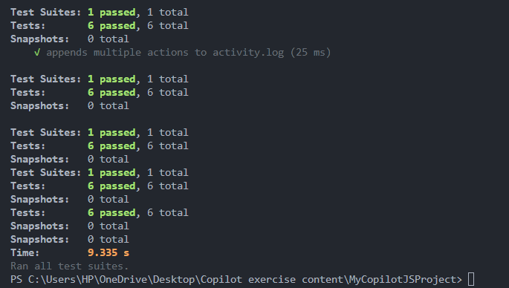
  2. Once all tests pass, (optionally) commit your changes:

| git add . git commit -m "Added logging feature in javascript with limited context" |
| --- |

Voila!! We have successfully completed this exercise.